**Leader Overview**

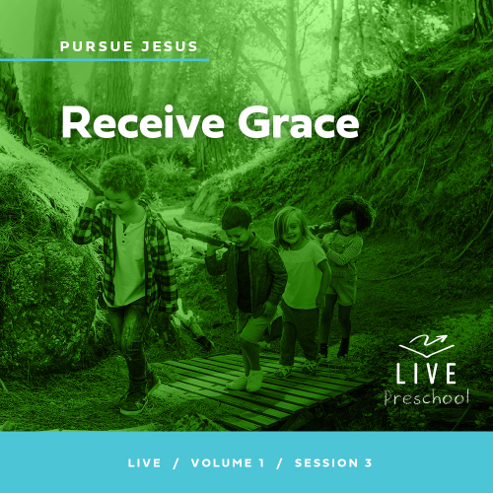

**Volume Overview**

**Pursue Jesus**

*Jesus’ offer is remarkably clear: If we look for Jesus, we’ll find Him. He’s not hiding from us, but closely connecting with Him does take us being intentional. We’re called to follow Him, to pursue Him. In this volume, we’ll look at how individuals pursued Jesus through the challenges of their circumstances. Pursuing Jesus is not only a mental exercise for personal growth, but it also means living out our faith in tangible ways: showing up, listening carefully, receiving grace, and trusting Him.*

**Session Overview**

***Receive Grace***

*In this* **Live** *session, preschoolers will discover that Jesus offers forgiveness for our sins through the Bible story of a woman who anointed Jesus’ feet. They’ll learn that they can always go to Jesus and ask Him to forgive them.*

**Bible Lesson**

A Sinner Comes Humbly to Jesus

[Luke 7:36–50](https://ref.ly/logosref/Bible.Lk7.36-50)

**Faith Fact**

I can be forgiven.

**Faith Verse**

[Jeremiah 29:13](https://ref.ly/logosref/Bible.Je29.13) (NLT)

“If you look for me wholeheartedly, you will find me.”

**Preparing for the Session**

**Leader Preparation Time: 20–25 Minutes**

|  |
| --- |
| ***You Will Need***  ***Preservice Activities***  *• Toys*  *• Leader’s choice for snack*  *•* ***Bible Story Warm-Up Pages****, one set per group*  *• Scissors*  *• Envelopes*  *• Bottle of perfume*  ***Large Group***  *• Bible*  *• Worship songs (Song suggestions: “Whoa, I Have Life” by Yancy and Little Praise Party; “Superhero” by Hillsong Kids; “What a Beautiful Name” Lyric Video by Hillsong Kids)*  *• For groups not using a phone or tablet only, add:*  *• Projector or TV*  *• Laptop*  *•* ***Faith Fact Sound*** *video (bell ringing)*  *•* ***Faith Fact Slide***  *•* ***Faith Verse Slide***  *•* ***Faith Verse Video***  *•* ***Bible Lesson Video A***  *•* ***Bible Lesson Video B***  ***Small Group***  *•* ***Small Group Activity Page****, one per kid.*  *• Pencils or pens, one per kid*  *• Markers or crayons*  *• Balloons, one per group*  *• Play dough*  *To access session content and videos from a computer, visit:* [***BibleEngagementProject.com/downloads***](https://bibleengagementproject.com/downloads) |
| ***Getting Ready***  ***Preservice Activities***  *• Set out toys and snacks.*  *• Print and cut apart the* ***Bible Story Warm-Up Pages****, one set per group.*  *• Place the picture sets into envelopes.*  ***Large Group***  *• Download videos and slides if needed.*  *• Select worship song(s) and have them ready to play.*  ***Small Group***  *• Print copies of the* ***Small Group Activity Page****, one per kid*  *• Inflate the balloon(s).*  ***First time leading* Live *for Preschool? Check out the*** [**Facilitator Guide**](https://0b769b0ed3569ef9d18b-f88d8272f61086866d50d048b43ef630.ssl.cf2.rackcdn.com/sites/biblengagementproject/Listen_Facilitator_Guide.pdf)***.*** |

**Preservice Activities**

*See what’s needed at the beginning of the session.*

**Bible Story Warm-Up**

Today, our Bible story is about someone who had made some bad choices. Then, she made a very good choice to find Jesus. I thought we’d look at some pictures of kids making choices. After we look at each picture, I’ll ask you to choose if the kids are making a good choice or a bad choice. If the person is making a good choice, you’ll run to one side of the room. *(Point where you want kids to go.)* But if the kids are making a bad choice, you’ll go to the other side of the room. *(Point where you want kids to go.)* Let’s play.

• *Show kids a picture. Ask kids to describe what’s happening. Then, ask the kids to choose if it’s a good choice or a bad choice and have them run to the spot for their answer.*

• *Call kids back to you. When a bad choice is found ask, “What would have been a better choice?”*

• *Optional: Place the pictures in good choice/bad choice stacks.*

Thanks for helping to decide if these pictures showed good or bad choices.

• *Have kids sit down by you. Ask these questions if you have time.*

Have you ever made a bad choice?

What happened when you made that choice?

What kind of choices make Jesus happy?

**Snack**

**Leader’s Choice**

Let’s enjoy our snack and pretend that we’re eating at a friend’s house for dinner.

• *Give kids the snack.*

In our Bible story today, Jesus went to a man’s home for dinner. While they were eating, a woman showed up with something special.

• *Hold up the perfume bottle.*

Is this something Jesus could eat? *(Group response)* Definitely not! What is it? *(Allow responses.)*

• *Optional: Spray perfume so kids can smell it.*

The woman brought perfume, and she chose to share it with Jesus. We’ll find out why in our Bible story time.

**Free Play**

*Any extra time can be spent playing with toys.*

**Transition**

*A few minutes before service begins have kids make their way to the large group area and sit in their designated areas.*

**Large Group**

**25 Minutes**

*See what’s needed at the beginning of the session.*

**Introduction**

Hi, friends! I’m so excited to be here with you today! We’re going to have a great time learning from God’s Word together. *(Hold up Bible.)* If you’re ready to have fun with your friends and discover a new Bible story, wave your hands with me. *(Group response)*

Today, we’ll find out about a woman who chose to give a very special present to Jesus. She had made some bad choices in her life, but she also knew Jesus could give her the forgiveness she needed. This Bible story shows us that Jesus forgave her. He can forgive us for our bad choices, too, when we ask Him to. I am so thankful for that!

**Faith Fact**

Jesus went to the Cross to pay for all the wrong things we do. When we go to Jesus and ask Him, Jesus forgives us. That’s what our Faith Fact is about today. **I can be forgiven.**

• *Show the* ***Faith Fact Slide.***

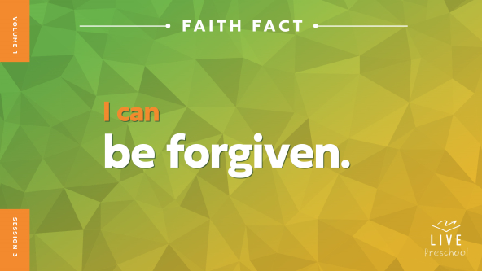

That’s the best news I’ve ever heard! Let’s say our Faith Fact together. **I can be forgiven.** When you have exciting news to share, do you just whisper it with a frown on your face? *(Demonstrate.)* No! Let’s say our Faith Fact with our biggest smile and shout with our loudest voice. **I can be forgiven.** Wow, I imagine that other people outside of this room could hear your good news! Great job!

**Bible Time**

*(Hold up the Bible.)* This whole book, the Bible, is full of good news, and we can find very important truths in it. Do you think Lizzy and Grandpa have a story from the Bible for us? *(Group response)* Let’s check in with them!

• *Play* ***Bible Lesson Video A.***

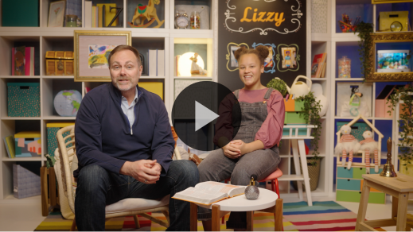

Grandpa gave us something important to think about. Let’s take some time to worship Jesus, and then we’ll come back and figure out what the woman in the Bible story did next.

**Worship**

We can worship Jesus by thinking about how good He is and by telling Him how thankful we are for Him.

**Praise**

Are you glad we can always go to Jesus? March in place. *(Group response)*

Who wants to thank Jesus for His forgiveness? *(Show the sign language sign for applause.)* Hold up your hands, spread your fingers, and wiggle your hands back and forth. *(Group response)*

Who wants to tell Jesus He’s more important than anything or anyone else in this world? Spin around one time. *(Group response)*

**Sing**

I like how you praised Jesus. Now, let’s use our voices to worship Him with singing.

• *Lead the kids in singing one or two songs. See song suggestions at the beginning of the session.*

**Prayer**

I’m so glad we can talk to Jesus anytime like He’s our best friend sitting next to us.

|  |
| --- |
| *Dear Jesus, You are more precious to us than anything we can ever hold with our hands. Thank You for loving us so much that You went to the Cross to forgive us of all the wrong things we do. We want to say yes to Your forgiveness. Amen.* |

**Bible Time cont’d**

• *Start* ***Bible Lesson Video B*** *and pause on the image of the two choices.*

It’s time for Lizzy and Grandpa to come back. Let’s all put on our thinking caps *(demonstrate)* and see if we can figure out what’s going to happen next in the Bible story. What do you think the woman chose to do? Did she go to the dinner and give her special gift to Jesus? *(Point to “gift” graphic.)* Or did she stay home and keep her special perfume? *(Point to “house” graphic.)*

If you think the woman gave her special gift to Jesus, hold out your arms like you’re giving a present. If you think the woman kept her jar of perfume, put your hands under your legs and sit on them. Ready? Choose your answer.

*Pause while kids respond.*

To find out if you’re right, let’s check back in with Lizzy and Grandpa.

• *Play* ***Bible Lesson Video B.***

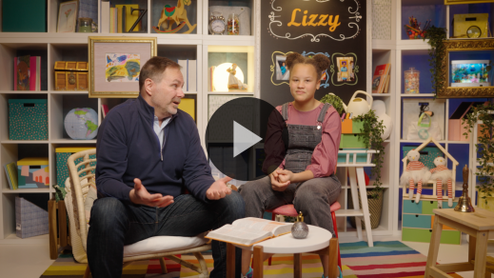

Wow! The woman in our Bible story loved Jesus very much! She shared her special perfume with Him. Then, Jesus forgave the woman who came to see Him even though she had done some pretty bad things. She was very thankful that Jesus had forgiven her.

**Response Time**

*Play a worship song quietly.*

Now, we’ll respond to what we’ve learned from the Bible today. Hold your hands over your heart like this *(demonstrate)*, and let’s pray together. Jesus forgives us the moment we ask Him to do it. Let’s think about things we need to ask Jesus to forgive us for.

• *Pause to give kids a short time to think.*

And now let’s pray together.

• *Have the kids repeat phrases of the prayer after you.*

|  |
| --- |
| *Dear Jesus, thank You for going to the Cross for me. I know You are God’s Son. I have done wrong things, and I ask You to forgive me. I want to do what’s right. I love You. Amen.* |

When Jesus looks at you after He has forgiven you, He doesn’t see all the wrong things you’ve done. He only sees you as someone who’s perfectly clean because He has forgiven you for all those wrong things.

**Faith Verse**

Our Faith Verse reminds me of the woman in our Bible story. We know she looked for Jesus wholeheartedly because she gave Him a special gift. We know she found Jesus because He forgave her. Let’s say our Faith Verse and do the actions together.

[Jeremiah 29:13](https://ref.ly/logosref/Bible.Je29.13) (NLT)

“If you look for me wholeheartedly, you will find me.”

• *Show the* ***Faith Verse Video****.*

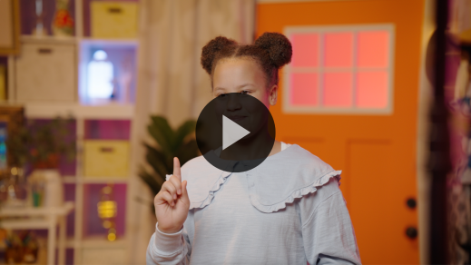

Wow, great job, friends! You’re learning that Faith Verse so well. Keep practicing, and we’ll say it again later.

**Closing**

Let’s clap our hands five times together to thank Jesus for His forgiveness. Ready? *(Clap as you count to five.)* 1, 2, 3, 4, 5! What a loud thank you! We’re having a great time together. We’ve worshipped Jesus by singing and praying. We practiced our Faith Verse, and we learned that we can be forgiven by Jesus.

• *Play the* ***Faith Fact Sound*** *video (bell ringing).*

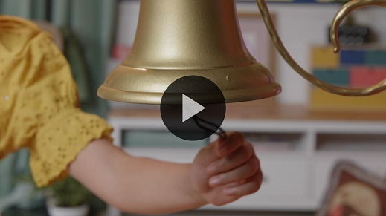

Oh, that sound means we should say our Faith Fact one more time: **I can be forgiven**.

• *Show the* ***Faith Fact Slide.***



Show me both your thumbs and then point them to your chest. Now, say the Faith Fact with me. **I can be forgiven**. Say it one more time. **I can be forgiven**.

**Dismissal to Small Groups**

That was so good! Now, we get to do some really special activities in our small groups.

• *Dismiss the kids by groups.*

|  |
| --- |
| ***Leader Tip:*** *This can be done by assigning color teams or by age groups. Note that some young preschoolers may not know their age. Using a colored sticker, jersey, or wristband will help separate the kids and help identify their small groups.* |

**Small Group**

**25 Minutes**

*See supplies and prep instructions at beginning of session or in each activity below.*

|  |
| --- |
| ***Leader Tip:*** *Small groups can alternate to each circle, or all groups can do each activity at the same time. If you choose to alternate, you will need at least one leader per circle.* |

**Circle 1**

**Group Connection**

**What Do My Friends Like?**

In our Bible story, the woman who brought the perfume and the people at the dinner got to know Jesus better, and He got to know them. Here’s what we’ll do to get to know each other better. I’ll ask a question. We’ll start with the person on my right. That kid will say their name and their answer to the question. Listen carefully to each other because I’ll ask questions about what some of our friends share.

• *After each question, ask kids about what the other kids shared. For example: Who shared about ____? What did (name) share?*

What’s something fun that you like to do?

Who shared something fun that you’d like to do, too?

In our Bible story, the woman gave Jesus a special gift. Who has given you a special gift and what did they give you?

If you could go and see Lizzy, what’s one thing you’d ask her?

What’s one question you want to ask me?

• *Ask additional questions if time allows.*

**Circle 2**

**Activity Page Time**

**Maze Match**

|  |
| --- |
| ***You Will Need***  *•* ***Small Group Activity Page****, one per kid.*  *• Pencils or pens, one per kid*  *• Markers or crayons*  ***Getting Ready***  *• Print copies of the* ***Small Group Activity Page****, one per kid.* |

Today, we learned that we have choices we can make. We want to make good choices that lead us to Jesus.

• *Give a copy of the* ***Small Group Activity Page*** *and a pencil to each kid.*

On your page, you can see the woman who wanted to give a special present to Jesus. Can you help her find the right path to Jesus?

• *Assist kids as needed.*

• *During the activity, interrupt and practice the Faith Fact:* **I can be forgiven.**

• *Play the* ***Faith Fact Sound*** *video****.*** *Review the Faith Fact even if you can’t play the sound.*



**Circle 3**

**Feet-to-Floor Game Time**

**Balloon Toss**

|  |
| --- |
| ***You Will Need***  *• Balloons, one per group*  ***Getting Ready***  *• Inflate the balloon(s).* |

Our Faith Verse today is:

[Jeremiah 29:13](https://ref.ly/logosref/Bible.Je29.13) (NLT)

“If you look for me wholeheartedly, you will find me.”

So let’s practice our Faith Verse another way. I’ll toss the balloon in the air. Every time someone hits it, they have to say the next word of our Faith Verse. Then, they’ll sit down away from the playing area until all the words have been said. So, I’ll hit the balloon and say, “If,” then I’ll go sit down. The next person to hit the balloon would say, “you,” and come sit by me. We’ll keep tossing the balloon and saying words of the Faith Verse until everyone has had a chance to hit the balloon.

• *Play as many times as you have time for.*

• *If it’s too difficult for each kid to say one word, then have the entire group say it all together.*

You did a great job remembering our Faith Verse and playing together!

**Circle 4**

**Hands-On Learning**

**Play Dough Perfume Jars**

|  |
| --- |
| ***You Will Need***  *• Play dough*  *No prep needed for this activity.* |

Do you remember what the woman in the Bible story poured on Jesus’ feet? *(Allow responses.)* That’s right! She poured perfume. She had it in a special jar and poured it on His feet. I think the woman’s perfume jar was very pretty. Let’s see if we can make perfume jars out of this play dough. Let’s work extra hard to make our perfume jars pretty and special, too. Maybe you want to take some of the play dough and make decorations on the outside of the jar.

• *Allow kids to make perfume jars.*

• *Encourage them as they show off the jars they’ve made.*

You did a great job! You are very creative artists!

**Dismissal**

• *Play the* ***Faith Fact Sound*** *video (bell ringing).*



• *Show the* ***Faith Fact Slide.***



Before we go, let’s say the Faith Fact together one last time. **I can be forgiven.** Great job! I had a great time learning from the Bible with you. See you next time!

• *Send home the* ***Small Group Activity Page*** *with each kid.*

• *Remind parents that there are* ***Family Devotions*** *available on the app to do with their kid.*

• *Tell everyone the date and time for the next session.*